**Relaxify – Your Leisure Time Companion**

**(Music Streaming Web App)**

**Project Documentation**

**Introduction**

**Project Title: Relaxify**

**Team Members:**

* + RESHMA BANU F (TEAM LEADER)
  + RAMYA S (TEAM MEMBER)
  + RUPA DEVI M (TEAM MEMBER)
  + RAJA SRI P (TEAM MEMBER)

**Project Overview**

**Purpose:**

Relaxify is a simple yet interactive web-based music streaming application. It provides users with an engaging interface to play, shuffle, loop, and search for their favorite songs. Additionally, it allows users to mark favorite songs and download music for offline listening

**Features:**

* **User Authentication:** Simple login system with local storage for session persistence.
* **Music Playback:** Play, pause, next, previous, loop, and shuffle songs.
* **Playlist Management:** Users can browse and search songs.
* **Favorites:** Users can add songs to favorites for quick access.
* **Download Functionality:** Users can download songs for offline listening.
* **Responsive UI:** Fully responsive design for seamless experience across devices.

**Architecture**

**Component Structure:**

* **Login Component:** Handles user authentication.
* **Music Player Component:** Controls music playback.
* **Playlist Component:** Displays the list of songs.
* **Favorites Component:** Shows user-favorited songs.
* **Search Component:** Allows users to search for songs.
* **Download Component:** Enables song downloads.

**State Management:**

State management is handled using **localStorage** to persist user login sessions and **JavaScript event listeners** for UI interactions.

**Routing:**

Since this is a simple web app, it primarily consists of two pages:

1. **Login Page:** login.html
2. **Music Player Page:** index.html

Redirection between pages is handled using JavaScript.

**Setup Instructions**

**Prerequisites:**

Ensure you have the following installed:

* Web Browser (Google Chrome, Firefox, etc.)
* Code Editor (VS Code, Sublime, etc.)

**Installation:**

1. **Clone the Repository**

git clone https://github.com/yourusername/relaxify.git

cd relaxify

1. **Run the Project**  
   Open index.html in a web browser.

**Folder Structure**

pgsql

CopyEdit

/relaxify

│── index.html (Music Player Page)

│── login.html (Login Page)

│── style.css (CSS for UI)

│── script.js (Main JavaScript file)

│── assets/

│ ├── songs/ (MP3 files)

│ ├── images/ (Icons & Backgrounds)

│── README.md (Documentation)

**Running the Application**

Simply open index.html in a web browser.

**Component Documentation**

**Key Components:**

1. **Login Component**
   * Handles authentication and redirects users to the music app.
2. **Music Player Component**
   * Allows play, pause, next, previous, shuffle, loop, and volume control.
3. **Favorites Component**
   * Enables users to mark and store favorite songs.
4. **Download Component**
   * Provides users with an option to download songs.

**State Management**

**Global State:**

* **localStorage** is used to persist login sessions and favorite songs.

**Local State:**

* JavaScript variables track the currently playing song, volume, and playback mode.

**User Interface**

**UI Design:**

* The user interface follows a clean, modern aesthetic with minimal clutter.
* Song cards are displayed in a grid layout for easy browsing.
* The color palette blends soothing gradients with vibrant highlights for dynamic visuals.

**Styling**

**CSS Frameworks/Libraries:**

* **Vanilla CSS** with gradients and box shadows for UI styling.

**Theming:**

* Custom dark mode theme with gradient backgrounds.

**Testing**

**Testing Strategy:**

* Manual testing for login, music playback, and download features.

**Code Coverage:**

* Basic console logging for debugging.

**Screenshots or Demo**

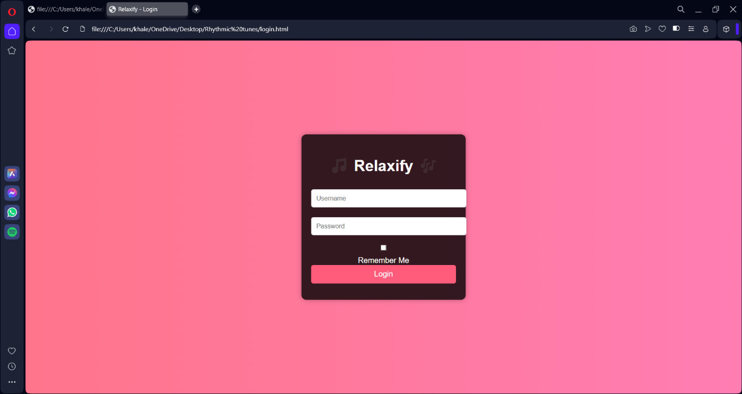

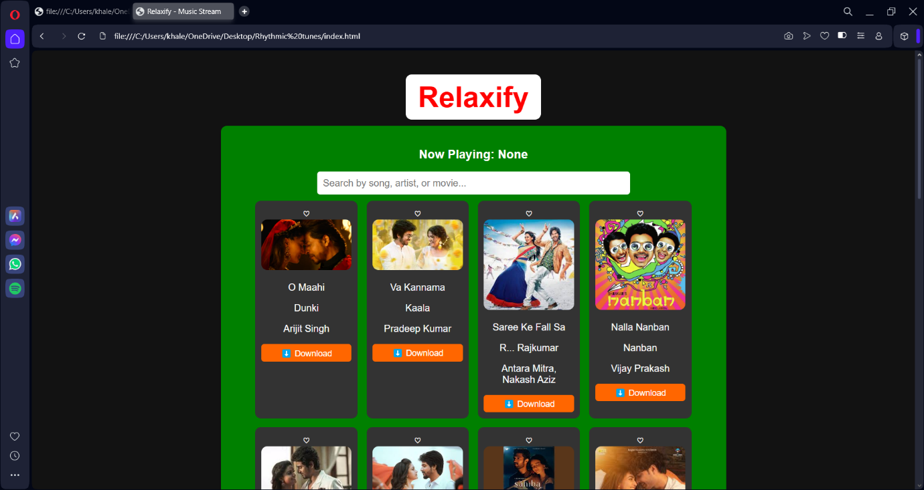

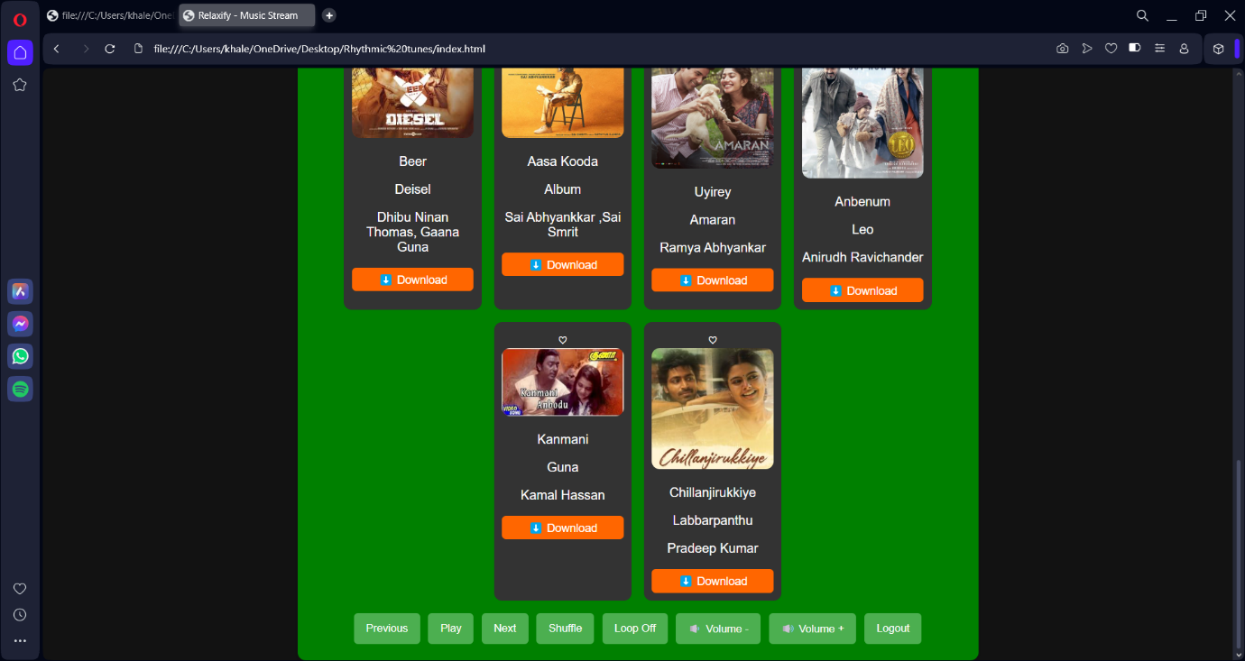

**Known Issues**

* No server-side authentication (uses only frontend validation).
* Some browsers may block automatic downloads due to security settings.

**Future Enhancements**

* **Cloud-based Playlist:** Users can save playlists online.
* **User Profiles:** Personalized recommendations based on listening history.
* **Social Sharing:** Allow users to share songs with friends.
* **Progress Bar Customization:** Enable users to seek specific song parts.